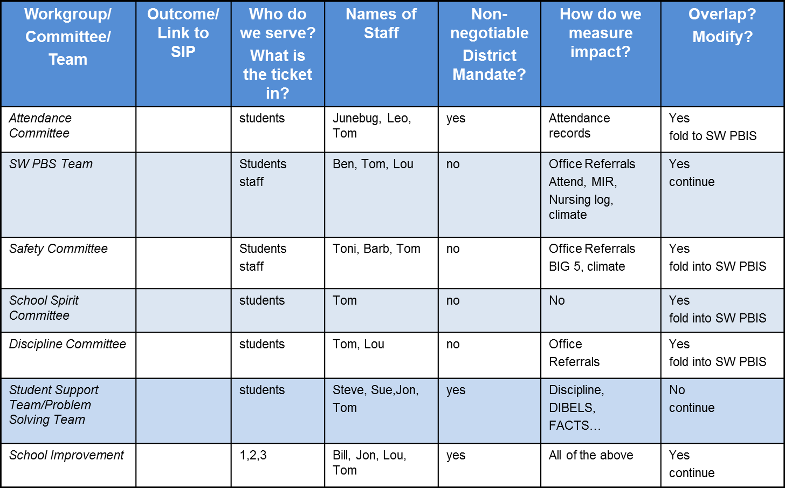

**Working Smarter-Systems/Staff Support**