The Advanced Tiers Spreadsheet

The Advanced Tiers Spreadsheet is a second option teams have available to collect and organize information in order to determine the function of behavior. The spreadsheet also doubles as a tool for data entry and progress monitoring of each student’s intervention data. The spreadsheet was created to hold data for up to 30 students. If more than 30 students participate in your school’s Tier 2 interventions, additional copies of the spreadsheet can be downloaded. The spreadsheet is available at no cost at www.pbismissouri.org.

The spreadsheet includes one tab for entering student information that is typically collected prior to the selection of an intervention (e.g., date, grade, gender, attendance, academic performance, ODR, function of behavior etc.). This tab allows teams to record much of the same information that is collected on the Tier 2 Adapted FACTS Part A. However, it does not include a context analysis and behavior pathway. Many teams take a “hybrid” approach and use the Tier 2 Adapted FACTS Part A for collecting student information and determining the function of behavior and the Advanced Tiers Spreadsheet for data entry and progress monitoring.

Advanced Tiers Spreadsheet: Main Menu
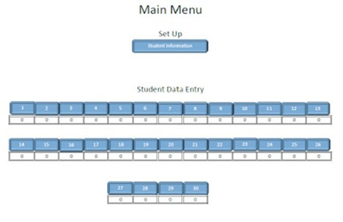

Figure 4.2

Advanced Tiers Spreadsheet: Student Information Tab

Student Name | IEP Status | Expectations Taught
Date of Identification | # Discipline Events (ODR) | Recognition Received
Method of Identification | # Classroom Events (minor) | Problem Behavior
Grade | # Absences | Function of Behavior
Gender | # Tardies | Intervention Selected (1)
Ethnicity | Academic Performance Level | Intervention Selected (2)
Race | Grade Point Average | Goal

Figure 4.3

The second page is where daily student performance data can be recorded. The spreadsheet is designed to automatically generate a graph of student progress when data is entered. In addition, a trend line also appears. The trend line is useful for determining positive, questionable, or poor response to the program.
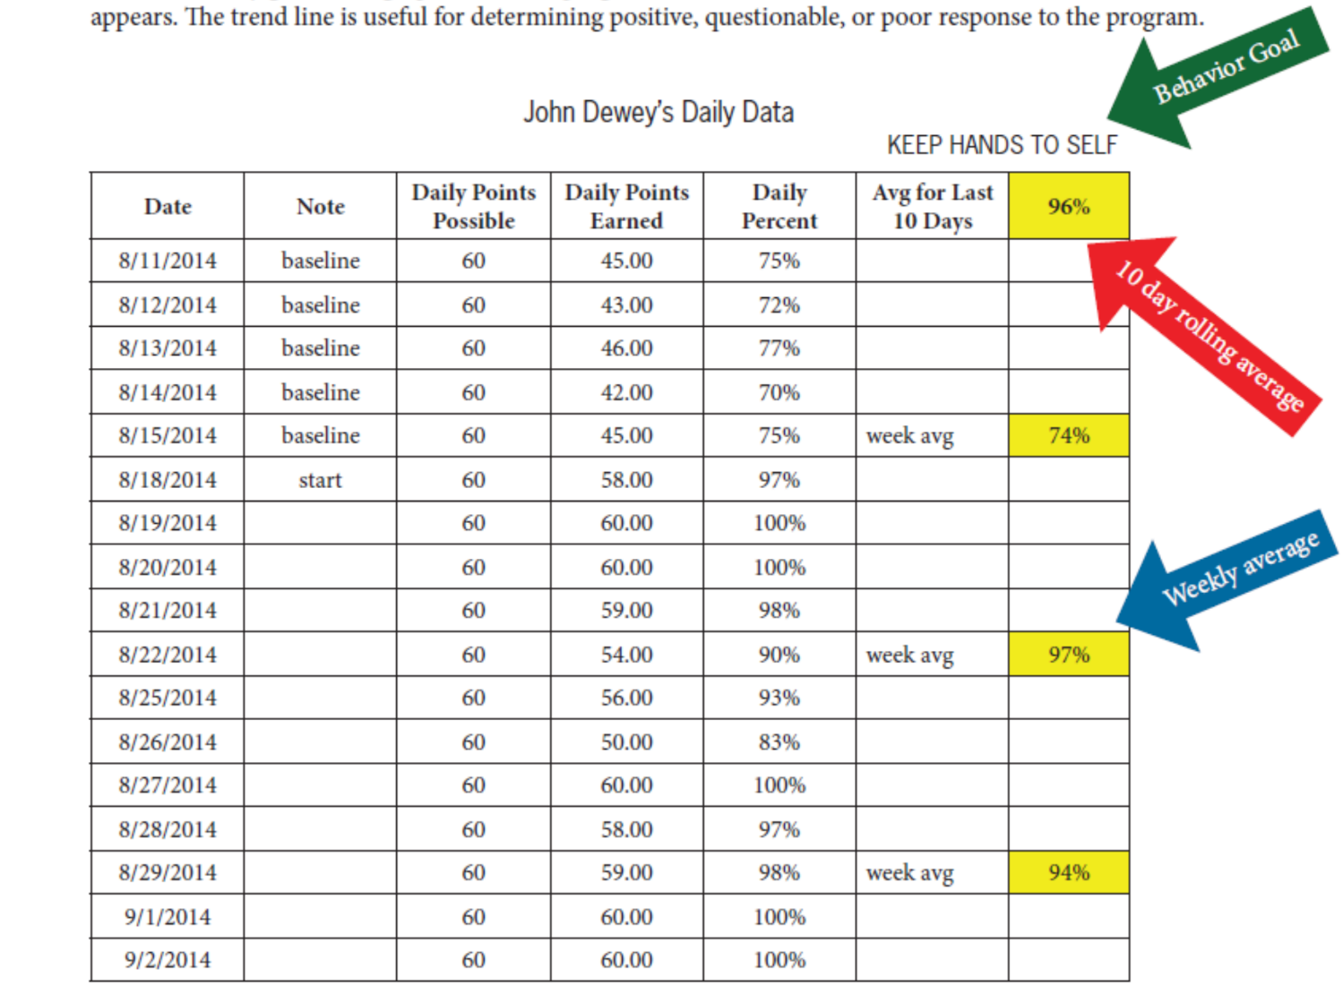
Figure 4.4
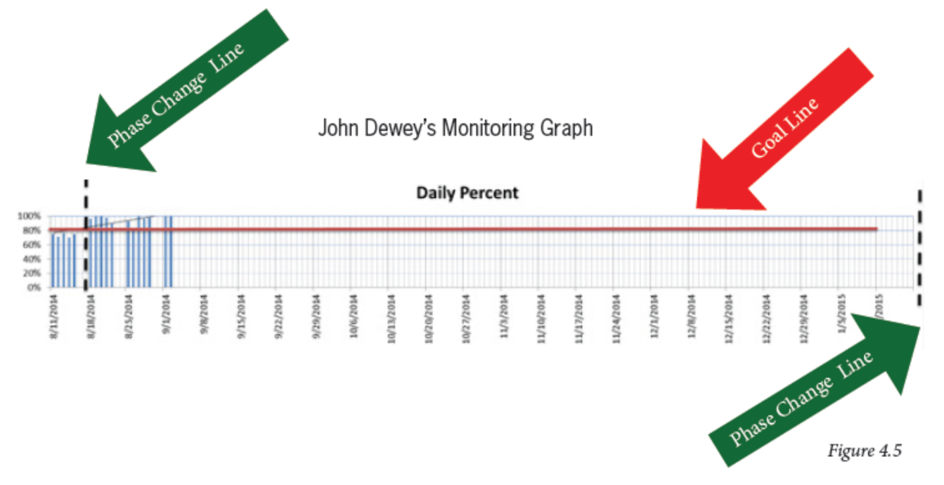
The graphs on the student data entry pages include a horizontal moveable goal line, as well as two vertical moveable phase change lines. The goal line can be moved to a target for daily percentage points that is appropriate for the individual student, and is based on the student’s baseline data. The phase change lines can be moved to coincide with a date when a change was made to the student’s plan. To move these lines, simply click and hold the left mouse button on the line, drag it to the desired location, and release the button. The previous graph for John Dewey shows that the horizontal goal line has been set at 80%, and one of the phase change lines has been moved to align with 8/18/2014 to indicate the transition from the baseline data collection phase to the start of the intervention phase. These lines can also be used to indicate a change in the intervention strategies.

In addition, the graph provides a trend line. This line helps the team to assess whether the student is making an adequate rate of progress to achieve his or her goal.

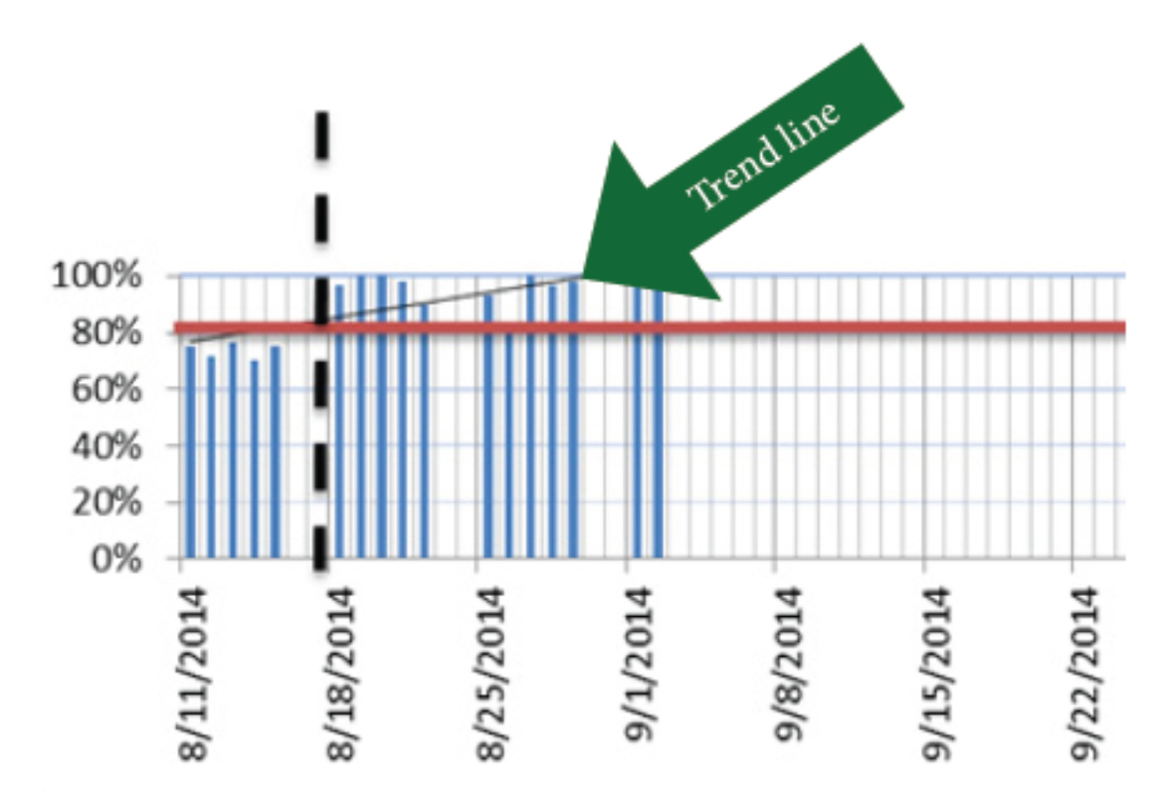
Figure 4.6
To use the Advanced Tiers Spreadsheet, first download a free copy from http://pbismissouri.org/tier-2-workbook/selecting-function-based-interventions-monitoring-data-and-using-data-for-decisions. The spreadsheet uses macros as part of the navigation buttons on the main menu and elsewhere on the spreadsheet. To use the spreadsheet, the macros must be enabled. Typically, the user of the spreadsheet will receive a warning that the “macros have been disabled” the first time the spreadsheet is opened. Click “enable this content” button to use the navigation buttons (see below).
Enable Conten

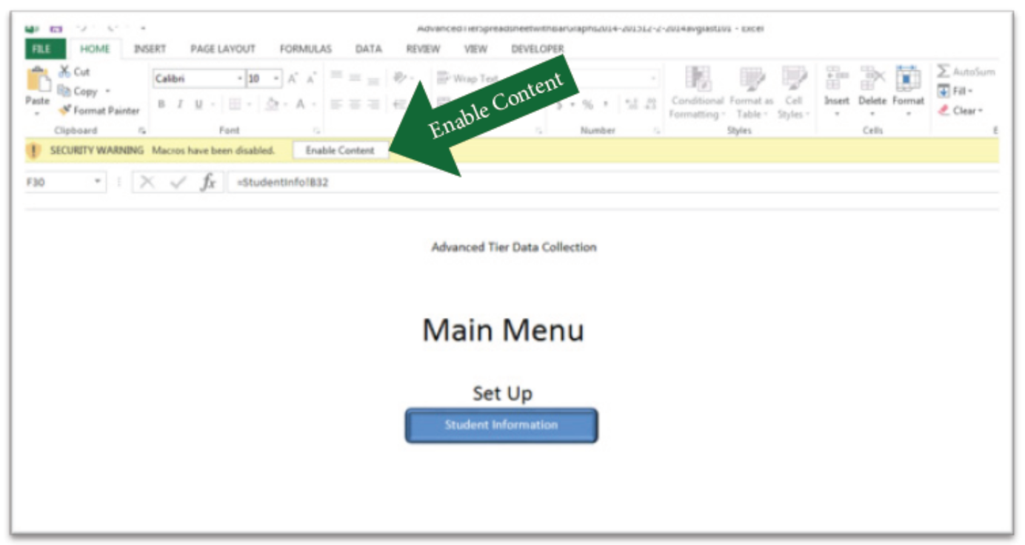
Figure 4.7

For each student that is enrolled in Check-In, Check-Out, complete the information on the student information page. Entering the student's name in the appropriate place on the student information page will cause his or her name to appear underneath a button on the main menu page, as well as at the top of that student's data entry page. This makes navigation much easier.

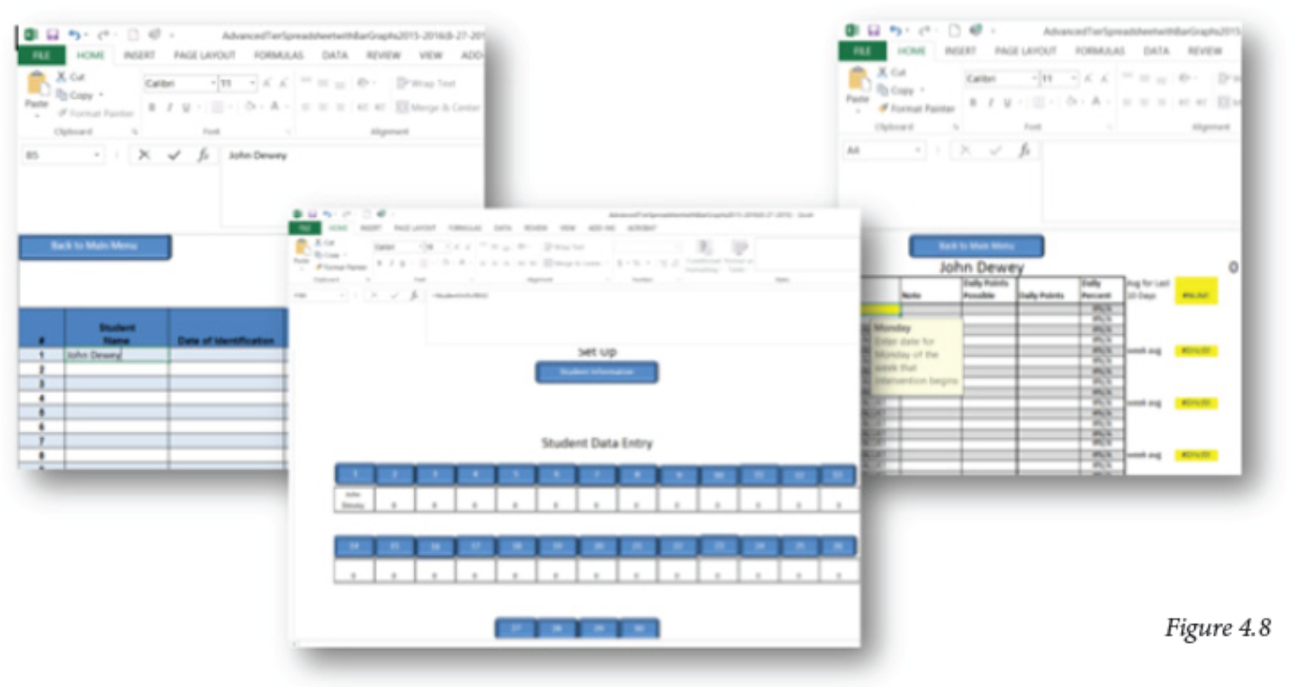

Prior to entering points, enter the date for the Monday that starts the week when the intervention begins in the yellow cell beneath the column header marked “Date.” It is important that the date in this cell is a Monday so that the “weekly averages” correspond with the Friday of each week. The Monday Start Date cell has a rule that will not allow entry of a date that does not fall on a Monday. If a non-Monday date is entered, the user will receive an error message, and must enter another date. For example, if an intervention is starting on October 1, 2015 (a Thursday), the user must enter September 28, 2015 in the Monday Start Date cell. Weekdays will automatically fill in for the date column. Users will begin entering points in the “daily points” cell that corresponds with “October 1.”
onday Start Date
Directions for Monday Start

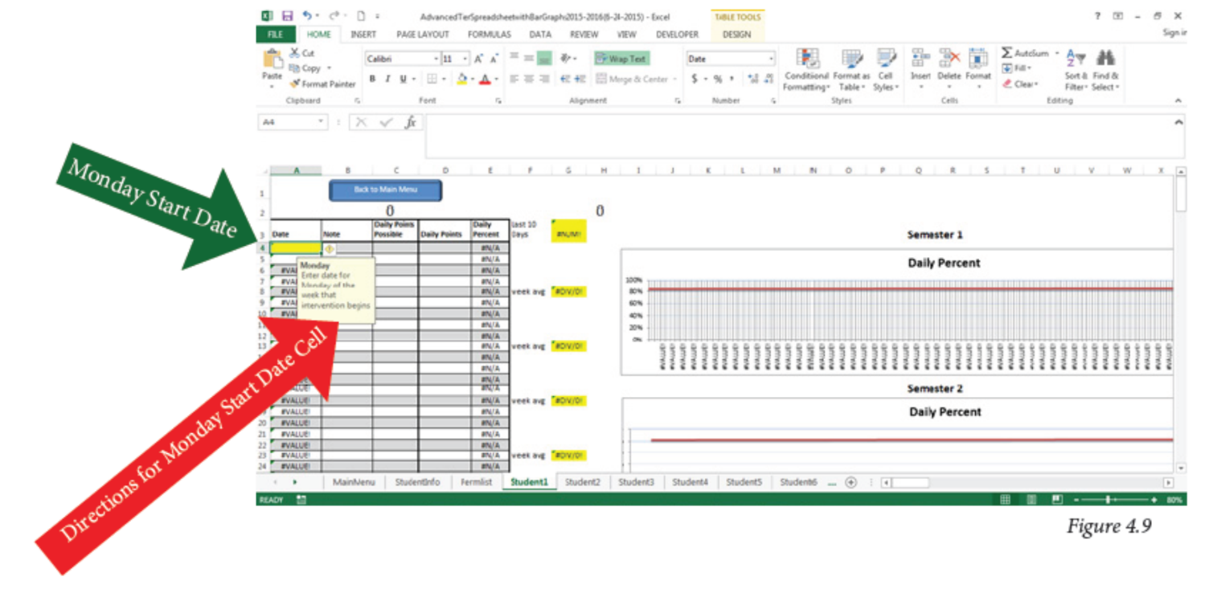

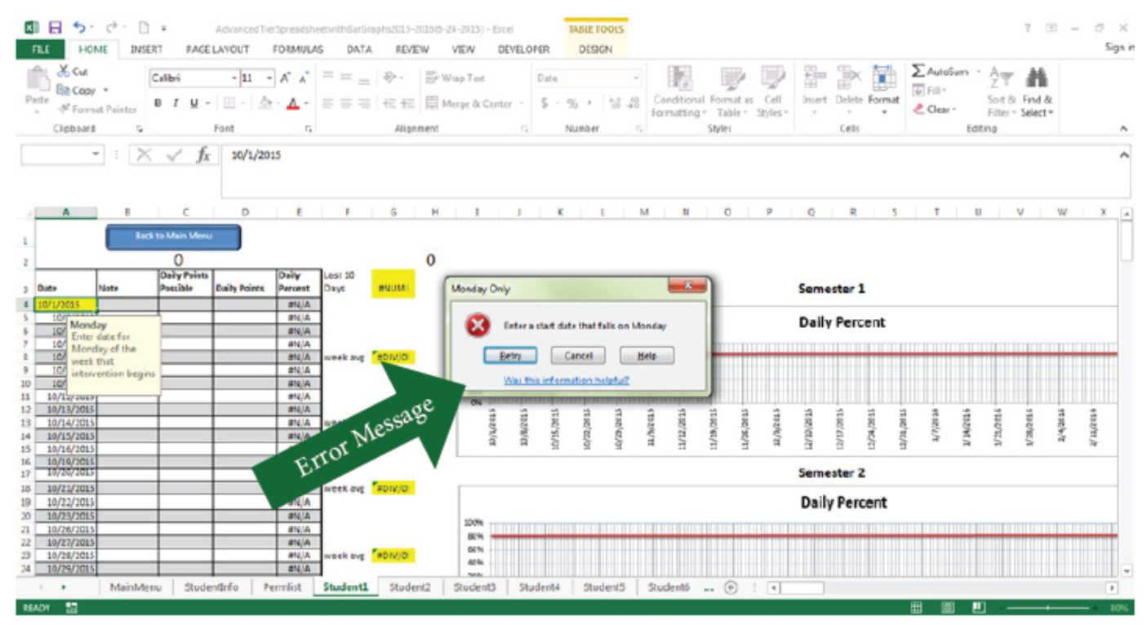
Figure 4.10
Error Messag
When entering daily points for individual students, it is important to only enter a score of “0” if that is the score that the student earned. “0’s” entered for the student on days when he or she was absent are interpreted by the spreadsheet as 0 points earned when the spreadsheet calculates the trend line, the weekly average, and the ten day rolling average. On days when the student is absent, the cell should be left blank, since blank spaces are not factored into these calculations. In addition, if a student is absent from a period, simply subtract the points possible for the missing period from the total points possible for the day, and enter this number in the “Daily Points Possible” cell for that date. For example, if there are three periods per day, each worth a total of 20 points, and the student missed one period, mark the total points possible for that day as 40 instead of 60.

Finally, with so many schools adopting the use of iPad for staff members and/or using Google Docs for shared documents, a Google Docs version of the Advanced Tiers Spreadsheet has been developed and is available free of charge. This spreadsheet, called Google Docs Advanced Tiers Spreadsheet, works on the iPad with the download of a free “Google Sheets” App. iPad users will also need a Google account and a free Google Docs app. PC users will simply need a Google Account.

This spreadsheet is very similar to the Advanced Tiers Spreadsheet, although minus certain features. The graphs do not include moveable goal or phase change lines. Another difference is that the spreadsheet does not have a navigable main menu page. Rather, the user must navigate using the tabs across the bottom of the spreadsheet. Tabs can be renamed with the student’s name by clicking on the downward pointing arrow on the tab, then clicking on “rename” from the menu and typing in the student’s name (important: this spreadsheet will contain confidential information; do not keep this spreadsheet in a shared folder unless sharing is restricted to individuals with “need to know” rights). However, there is a student information page that is aligned to the Tier 2 Adapted FACTS, and the graphs generate a trend line when the spreadsheet is opened using a laptop or desktop computer. Data can be entered using an iPad, and the graphs will automatically refresh as data is entered. However, the trend line will not appear when the sheet is opened using an iPad.

The Google Docs Advanced Tiers Spreadsheet can be accessed at http://pbismissouri.org/archives/5252. First, the user must sign into his or her Google Drive account. Then click on the link for “Google Docs Advanced Tier Spreadsheet.” An un-editable version of the spreadsheet will open. Click on the “File” menu, and then “make a copy.” This will load a clean, editable copy of the spreadsheet into your Google Docs folder. The spreadsheet can then be used or shared like any other Google Docs document.

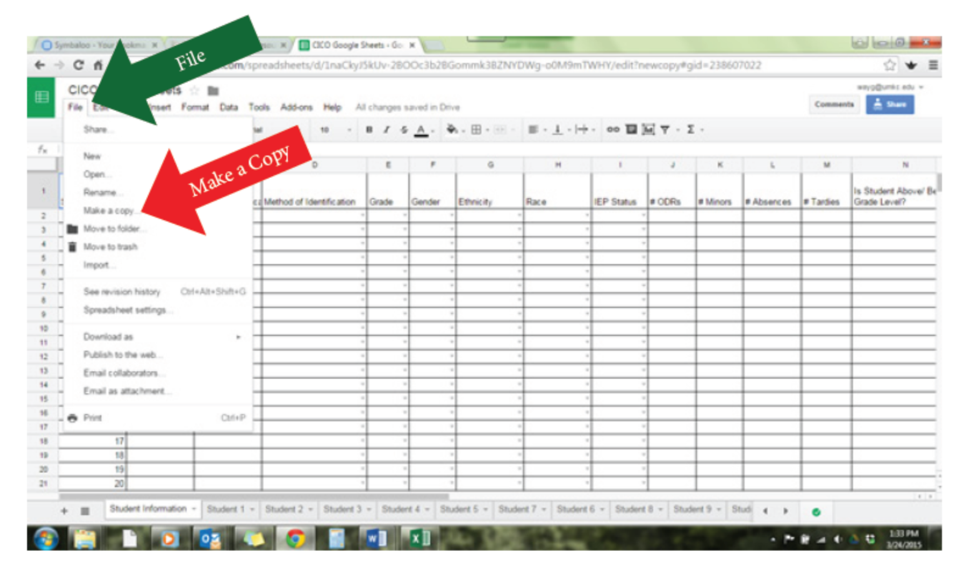
Figurt4.ll

