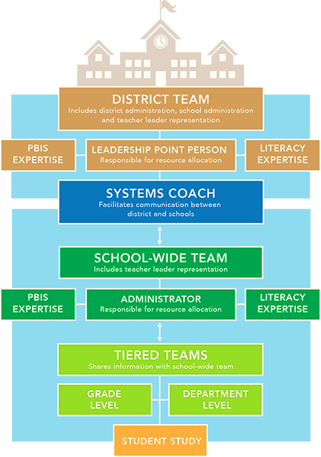
Example of RTI or MTSS District-wide Leadership Structure

