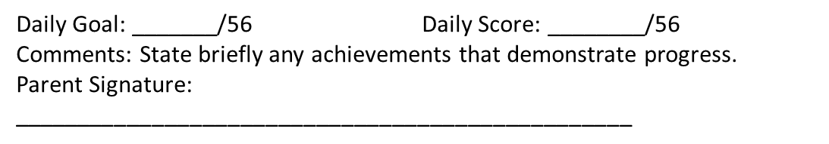**CICO Daily Progress Reports – Elementary Examples**

Name: _________________________________ Date:­___________

Homeroom Teacher: _____________________________________

