IN-SCHOOL BEHAVIOR EXPECTATIONS | Examples of posters to remind everyone of the new expectations | School-wide and in-class behaviors
Be Responsible | 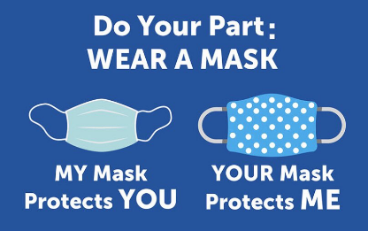 | - Wear a mask to school  - Keep hands to yourself  - Keep all your materials to yourself  - Avoid touching other people’s materials
Be Respectful | 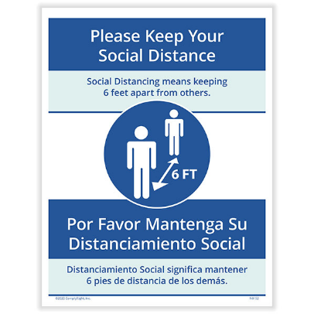 | - Be kind to each other  - Be patient when activities take longer than usual  - Maintain a safe distance of 6 feet from others  - Wear your mask, except while eating
Be Safe | 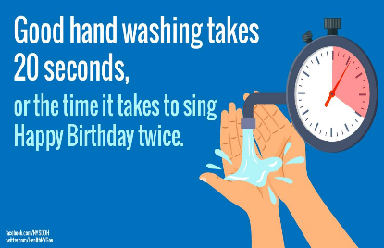 | - Wash hands for at least 20 seconds  - Avoid touching your mask or your face  - Use hand sanitizer often  - Tell teacher or nurse if you don’t feel well
Expectations for In-School Behavior (for COVID-19 safety)

