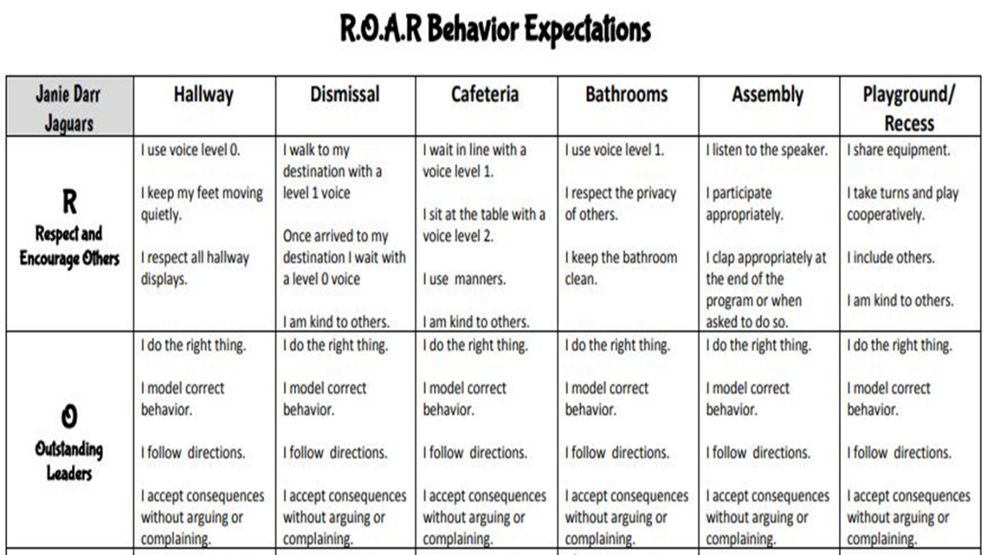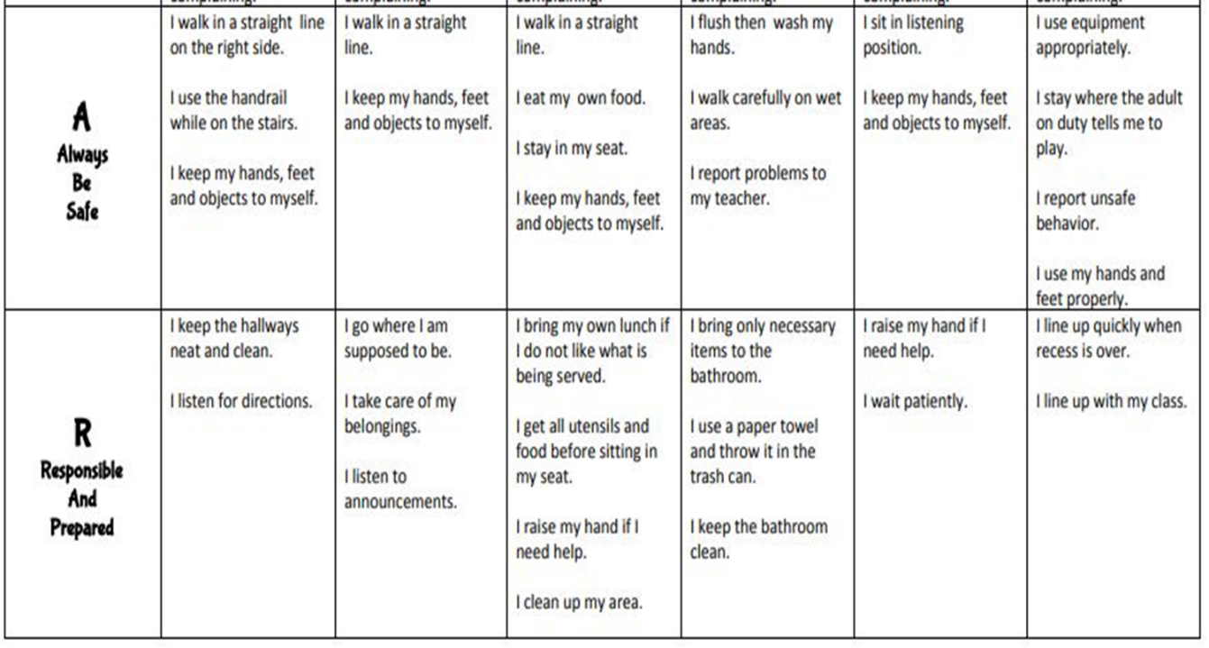



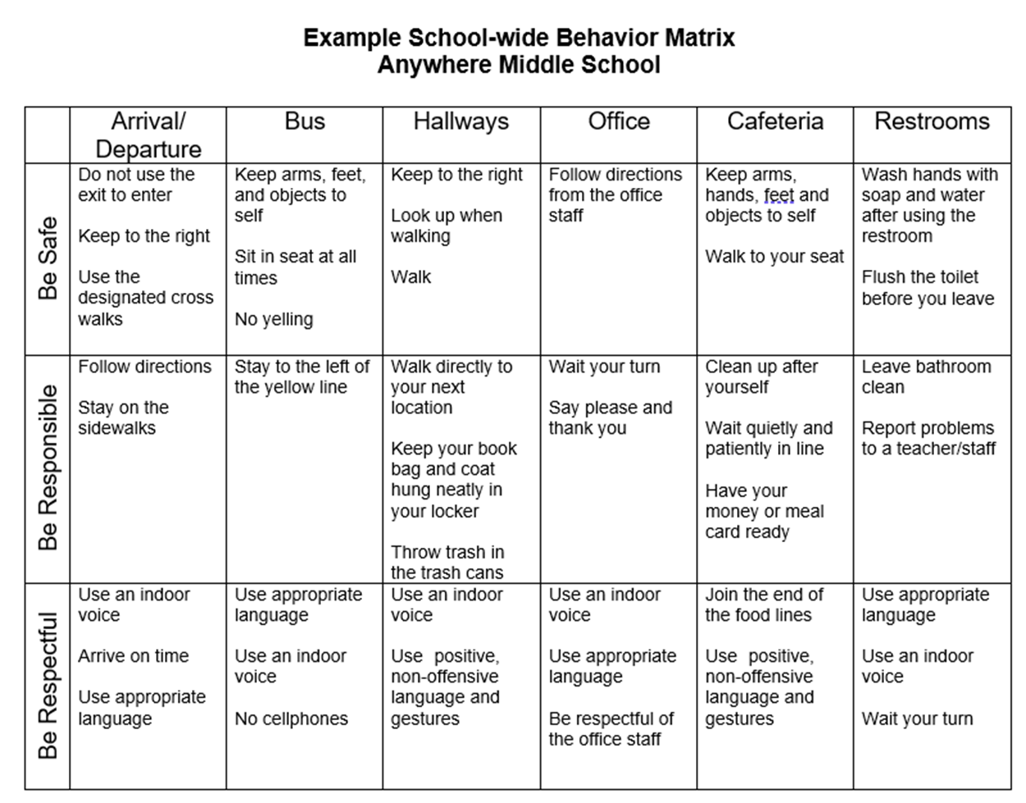

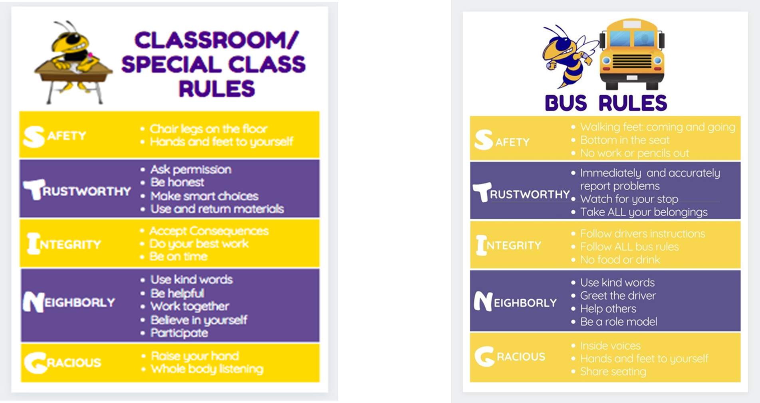



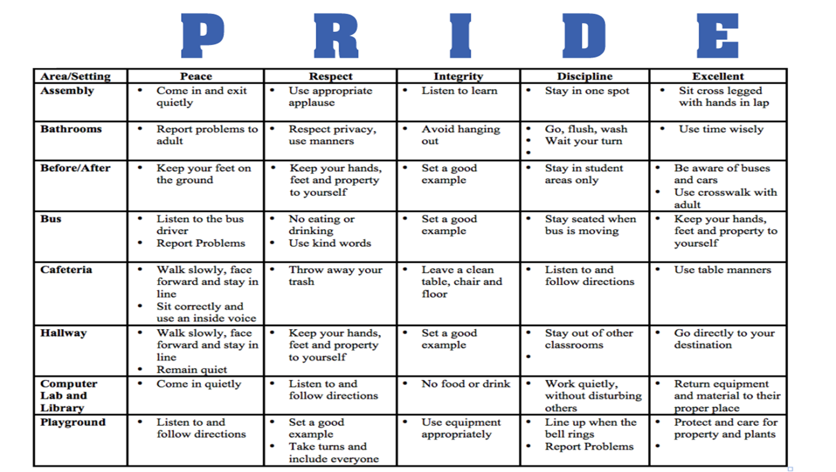

|  |  |  |  |  |  |  |  |
| --- | --- | --- | --- | --- | --- | --- | --- |
| **Behavior Expectation Matrix** | | | | | | | |
| Location   Expectations  ← | Bathrooms | Buses/Lines | Cafeteria | Classroom and Instructional Areas | Hallways and Common Areas | Playground | Special Events, Assemblies, Field Trips, Extra-Curricular |
|  |  |  |  |  |  |  |  |
|  |  |  |  |  |  |  |  |
|  |  |  |  |  |  |  |  |